Membership at your co-op

<insert co-op logo>

Package Contents:
- Introduction into co-op membership
- What is a housing co-op FAQ
- Co-operative principals

Introduction
This resource is designed to help understand what housing co-op membership means and how it works.
Co-ops are based on the values of self-help, self-responsibility, democracy, equality, equity, and solidarity. Housing co‑ops are guided by international co‑operative principles, please review the attached co-operative principles adapted for housing co‑ops.
Members elect a board of directors to oversee governance and make strategic decisions. Membership comes with rights, responsibilities, and opportunities to shape your community.

Your Co-op
<Insert co-op’s history – when incorporated, vision, mission, and core values>
________________________________________________________________________________________________________________________________________________________________________________________________________________________________________________________________________________________________________________________________________________________________________________________________________________________________________________________________________________________________________________________________________________________________________________________________________________________________________________________________________________________________________________________________________________________________________________________________________________________________________________________________________________________________

Legal Structure
Each level of authority builds on the one above it, and none can contradict the other. Most importantly, Human Rights legislation and other laws override everything else your co-op cannot adopt bylaws or policies that break the law or Provincial Co-op Act.
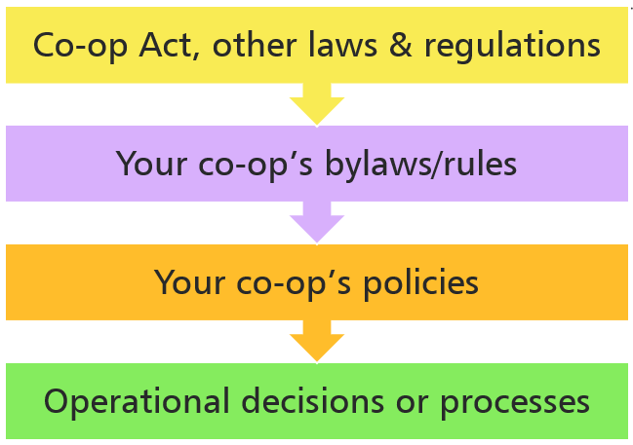

Hierarchy of Authority:
- Co-op Act and other laws & regulations
These set the legal foundation for co-operatives and include compliance with the Human Rights Act.
- Your Co-op’s bylaws/rules
Legal Document that outlines the rules governing how the Co-operative is run, defining its operations, decision-making, and member rights, as permitted and required by the Co-operative Associations Act. Approved by members.
- Your Co-op’s policies
Detailed operational guidance, aligned with bylaws/rules and legislation.
- Operational decisions or processes
Day-to-day actions that must follow policies, bylaws, and laws.

Co-ops often have mortgages, funding agreements or operating agreements. These contracts, along with the laws mentioned earlier, must be taken into account when drafting bylaws, policies, or processes to ensure compliance. These contracts and laws may require:

Financial reporting

Rules for subsidy disbursement

Spending thresholds

Other compliance obligations
The Current Policies are as follows:
- <insert>
- <insert>
- <insert>

Organizational Structure
The Board of Directors is elected by the membership. The Board is responsible for hiring and overseeing the property management company and any other contracted professional services except for the auditor, who is appointed directly by the members. The Board reports to the auditor on the co-op’s financial affairs.
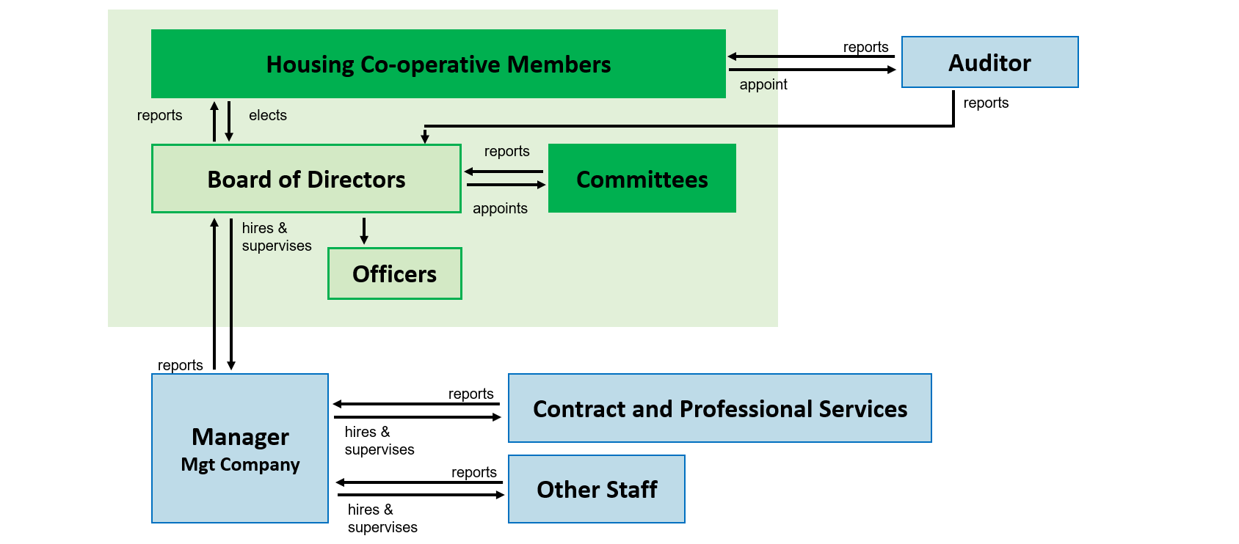
Officers and committee members may be appointed or approved by the Board. However, they do not have individual authority, the Board acts collectively to manage the co-op’s operations and is ultimately accountable to the membership.

Benefits of Membership

Non-Member/Tenant | Member
No voting rights | One vote per member
Informed of decisions | Participates in decision-making
Must follows policies | Approves the policies and bylaws that they are required to follow
Pays rent (housing charges) | Approves budgets and financials including the housing charges they pay
Cannot join governance | Can run for the board

Frequently Asked Questions
Where can I find co-op policies and resources?
Visit your co-op’s online resource library or request from your property manager.

How often does the co-op meet?
- Board meetings (for elected Board Members): Monthly <insert regular occurrence of meeting ie. 3rd Monday of every month>.
- General membership meetings (for all Members): Twice per year typically in <insert month> and <insert month>.
  - Annual General Meeting (AGM): A yearly meeting where members receive reports, elect the board, and review the co-op’s overall direction.
  - Budget Meeting: A meeting where members review and vote on the co-op’s proposed budget, including housing charges for the upcoming year.
- Special meetings (for all Members): Held as needed for major decisions i.e. Bylaw change, borrowing.

What are members expected to do to support the housing co-op?
- Pay housing charges on time
- Care for their unit and be a good neighbour
- Understand the co-op’s democratic structure
- Follow co-op policies and bylaws
- Attend general meetings
- Vote and/or run for board elections
- Appoint the auditor and approve audited financial statements
- Stay engaged and informed

What is the co-op required to do for the members?
The co-op is responsible for:
- Maintaining the buildings
- Managing day-to-day operations
- Ensuring financial reserves are funded for future repairs
- Providing members with education opportunities and resources
- Encouraging member engagement and participation in governance

How are units filled?
Units are allocated based on your co-op’s Unit Allocation Policy, which may prioritize those facing housing challenges. Internal and external waitlists are maintained.

How do I run for the board of directors?
Any member in good standing can be nominated or self-nominate. Elections are held during the AGM.

How will I receive notices and updates?
Meeting notices and communications are sent via email (with written member consent, as required in Ontario) or by mail for members without access or where required by the bylaws.

How can I get involved in the co-op community?
- Attend meetings and events
- Join committees or working groups
- Share feedback regularly and when requested

Contact & Support
For questions, maintenance, or grievances, contact your co-op’s property management team. <insert contact>

Notes:
________________________________________________________________________________________________________________________________________________________________________________________________________________________________________________________________________________________________________________________________________________________________________________________________________________________________________________________________________________________________________________________________________________________________________________________________________________________________________________________________________________________________________________________________________________________________________________________________________________________________________________________________________________________________________________________________________________________________________________________________________________________________________________________________________________________________________________________________________________________________________________________________________________________________________________________________________________________________________________________________________________

